

Data Science
Project Document Topic:
Chronic Kidney Disease Prediction Using Machine Learning

Submitted to: Maam Andleeb
Ameer Hamza
B-29425
Mohsin Malik
B-29426

Table Of Content

1. Introduction 2
2. Project Overview 2
3. Problem Statement 2
4. Objectives 3
5. Dataset Description 3
Features Used 3
Target Variable 3
6. Methodology 3
Phase 1: Data Collection 4
Phase 2: Data Preprocessing 4
Phase 3: Feature Engineering 4
Phase 4: Model Development 4
7. Machine Learning Models Used 4
Logistic Regression 4
K-Nearest Neighbors (KNN) 4
Support Vector Machine (SVM) 4
Random Forest Classifier 5
Gradient Boosting Classifier 5
8. Model Training 5
9. Model Evaluation 5
Accuracy 6
Precision 6
Recall 6
F1-Score 6
ROC-AUC Score 6
10. Results and Discussion 6
11. Feature Importance Analysis 6
12. Conclusion 7
13. Future Work 7

1. Introduction
Chronic Kidney Disease (CKD) is a long-term medical condition in which the kidneys gradually lose their ability to filter waste products and excess fluids from the blood. According to medical research, CKD is one of the leading causes of serious health complications worldwide. Early diagnosis of CKD is essential because delayed detection can result in kidney failure, cardiovascular diseases, and other life-threatening complications.
With the advancement of Artificial Intelligence and Machine Learning, healthcare systems can now utilize predictive models to assist doctors in diagnosing diseases more accurately and efficiently. Machine Learning algorithms are capable of analyzing large amounts of medical data and identifying patterns that may not be easily recognized through traditional diagnostic methods.
This project focuses on predicting Chronic Kidney Disease using Machine Learning techniques. The aim is to develop a predictive system that can analyze patient medical information and determine whether a patient is likely to have CKD or not. Multiple Machine Learning algorithms were implemented and compared to identify the most effective model for disease prediction.

2. Project Overview
The Chronic Kidney Disease Prediction System is a Machine Learning-based healthcare project designed to assist in the early detection of kidney disease. The project uses patient medical records and clinical measurements as input data and applies different classification algorithms to predict the presence of CKD.
The project includes data preprocessing, exploratory data analysis, feature engineering, model training, model evaluation, and performance comparison. Five Machine Learning algorithms were used in this project:
- Logistic Regression
- K-Nearest Neighbors (KNN)
- Support Vector Machine (SVM)
- Random Forest Classifier
- Gradient Boosting Classifier
The performance of these models was compared using different evaluation metrics such as Accuracy, Precision, Recall, F1-Score, and ROC-AUC Score. The best-performing model was selected as the final prediction model.

3. Problem Statement
Diagnosing Chronic Kidney Disease at an early stage can be challenging because symptoms often appear gradually. Traditional diagnosis may require several medical examinations and laboratory tests. There is a need for an intelligent prediction system that can assist healthcare professionals by providing quick and accurate disease predictions based on patient medical data.

4. Objectives
The main objectives of this project are:
- To analyze Chronic Kidney Disease patient data.
- To perform data cleaning and preprocessing.
- To visualize important medical features.
- To train multiple Machine Learning models.
- To compare the performance of different algorithms.
- To identify the best-performing prediction model.
- To assist in the early detection of CKD.

5. Dataset Description
The dataset contains medical and clinical information collected from patients.

Features Used
- Age
- Gender
- BMI
- Systolic Blood Pressure
- Serum Creatinine
- Education Level
- Socioeconomic Status
- Other medical attributes

Target Variable
Diagnosis
- 0 = No CKD
- 1 = CKD
The target variable represents whether the patient is diagnosed with Chronic Kidney Disease or not.

6. Methodology
The project was completed through the following phases:

Phase 1: Data Collection
The CKD dataset was collected and loaded into the Python environment for analysis.

Phase 2: Data Preprocessing
Data preprocessing was performed to improve data quality.
Activities included:
- Handling missing values
- Removing invalid entries
- Data cleaning
- Feature scaling
- Data transformation

Phase 3: Feature Engineering
Feature engineering techniques were applied to improve model performance.
These included:
- Feature selection
- Data normalization
- Feature importance analysis

Phase 4: Model Development
Multiple Machine Learning algorithms were trained using the prepared dataset.

7. Machine Learning Models Used

Logistic Regression
Logistic Regression was used as a baseline classification model. It predicts the probability of CKD occurrence using a logistic function.

K-Nearest Neighbors (KNN)
KNN classifies patients based on the similarity of neighboring data points. The prediction is made using the majority class among the nearest neighbors.

Support Vector Machine (SVM)
SVM is a supervised learning algorithm that identifies the optimal decision boundary between CKD and non-CKD patients.

Random Forest Classifier
Random Forest is an ensemble learning method that combines multiple decision trees to improve prediction accuracy and reduce overfitting.

Gradient Boosting Classifier
Gradient Boosting improves prediction performance by sequentially correcting errors made by previous models.
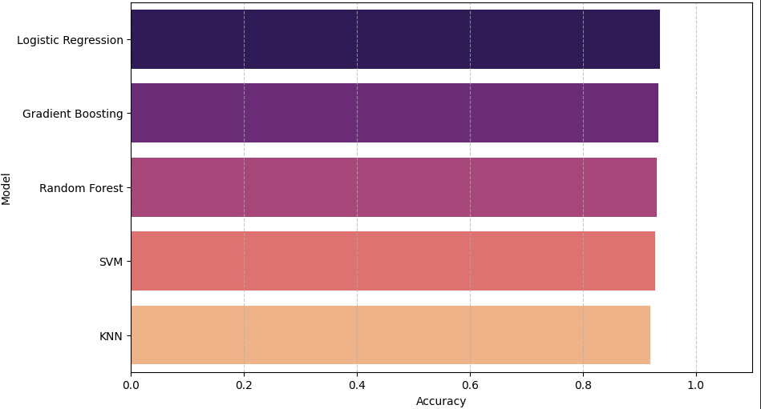

8. Model Training
The dataset was divided into training and testing sets.
- Training Data: Used for model learning.
- Testing Data: Used for performance evaluation.
Each Machine Learning algorithm was trained using the same dataset for fair comparison.

9. Model Evaluation
The following evaluation metrics were used:

Accuracy
Measures the percentage of correctly classified instances.

Precision
Measures how many predicted CKD cases were actually CKD patients.

Recall
Measures how many actual CKD cases were correctly identified.

F1-Score
Provides a balance between Precision and Recall.

ROC-AUC Score
Measures the model's ability to distinguish between CKD and non-CKD patients.

10. Results and Discussion
After training and evaluating all Machine Learning models, their performances were compared using various evaluation metrics.
The comparison showed that ensemble-based models such as Random Forest and Gradient Boosting generally achieved higher prediction accuracy compared to traditional models. KNN and SVM also produced competitive results and contributed to performance comparison.
The final selected model demonstrated strong capability in identifying CKD patients with high accuracy and reliability.

11. Feature Importance Analysis
Feature Importance analysis was performed using the Random Forest algorithm.
The analysis identified the most influential medical attributes affecting CKD prediction. Understanding these important features can help healthcare professionals focus on critical risk indicators during diagnosis.
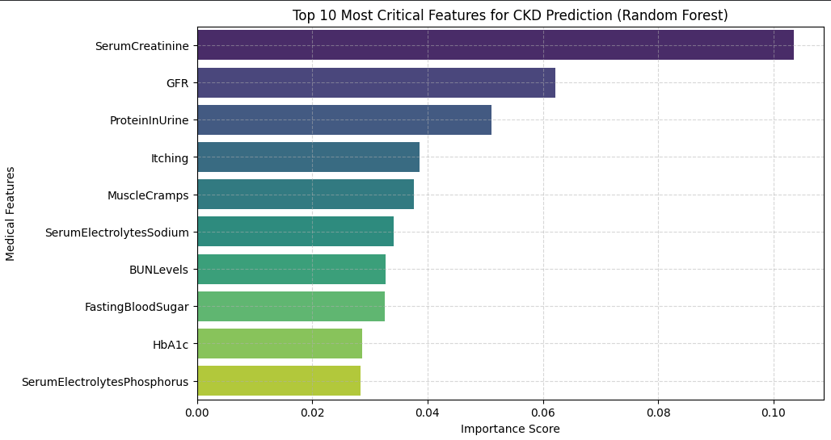

12. Conclusion
This project successfully developed a Machine Learning-based system for Chronic Kidney Disease prediction. Data preprocessing, exploratory data analysis, feature engineering, and model comparison techniques were applied to build an effective prediction system.
Five Machine Learning algorithms including Logistic Regression, KNN, SVM, Random Forest, and Gradient Boosting were implemented and evaluated. The results demonstrated that Machine Learning can effectively assist in the early detection of Chronic Kidney Disease and support healthcare decision-making.

13. Future Work
Future improvements for this project may include:
- Using larger healthcare datasets.
- Developing a web-based prediction application.
- Integrating real-time patient monitoring systems.
- Applying Deep Learning techniques.
- Improving prediction accuracy through advanced feature engineering and hyperparameter tuning.

